Contents

OOTB Webparts 1

Site pages 2

Web Part Pages 2

1.Apps 4

Examples 4

2.Blog 6

5. Content RollUp 7

4.1 Content Search 7

Summary Links 10

Configure style and layout 11

Promoted Links 13

To add Promoted Link to web parts 14

To change the Image 14

RSS Viewer 14

Filter: Query String: 16

Media and Content 22

Add Script Editor 23

Add Content Editor 24

How to Add content Editor page by Link 24

**Class 9**

# OOTB Webparts

**OOTB = out of the box, means without any code, simply by clicking**

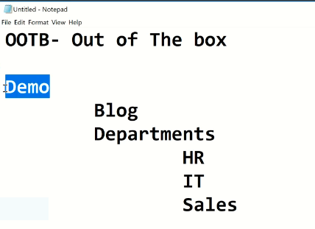

From the above we have 1 Root site and 5 sub sites

To check how many subsites we have follow the following steps

Site content => in modern form(Subsite) or in classic Look at the bottom of the promoted links .

So in my case I have

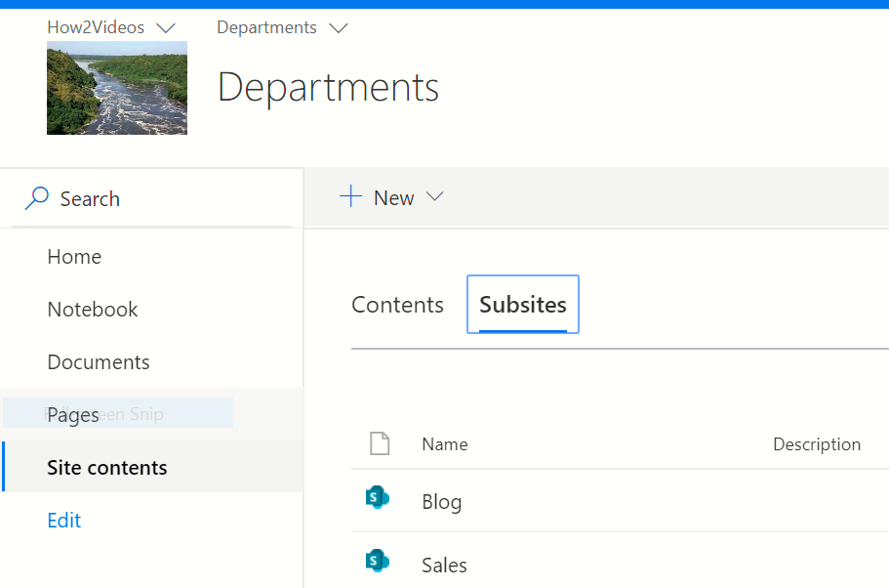

## Site pages

Site content => site pages

**Web part page and wiki part page**

### Web Part Pages

**New => web part pages => Name(PlayGroundWP) => Create, then web part zone is existed**

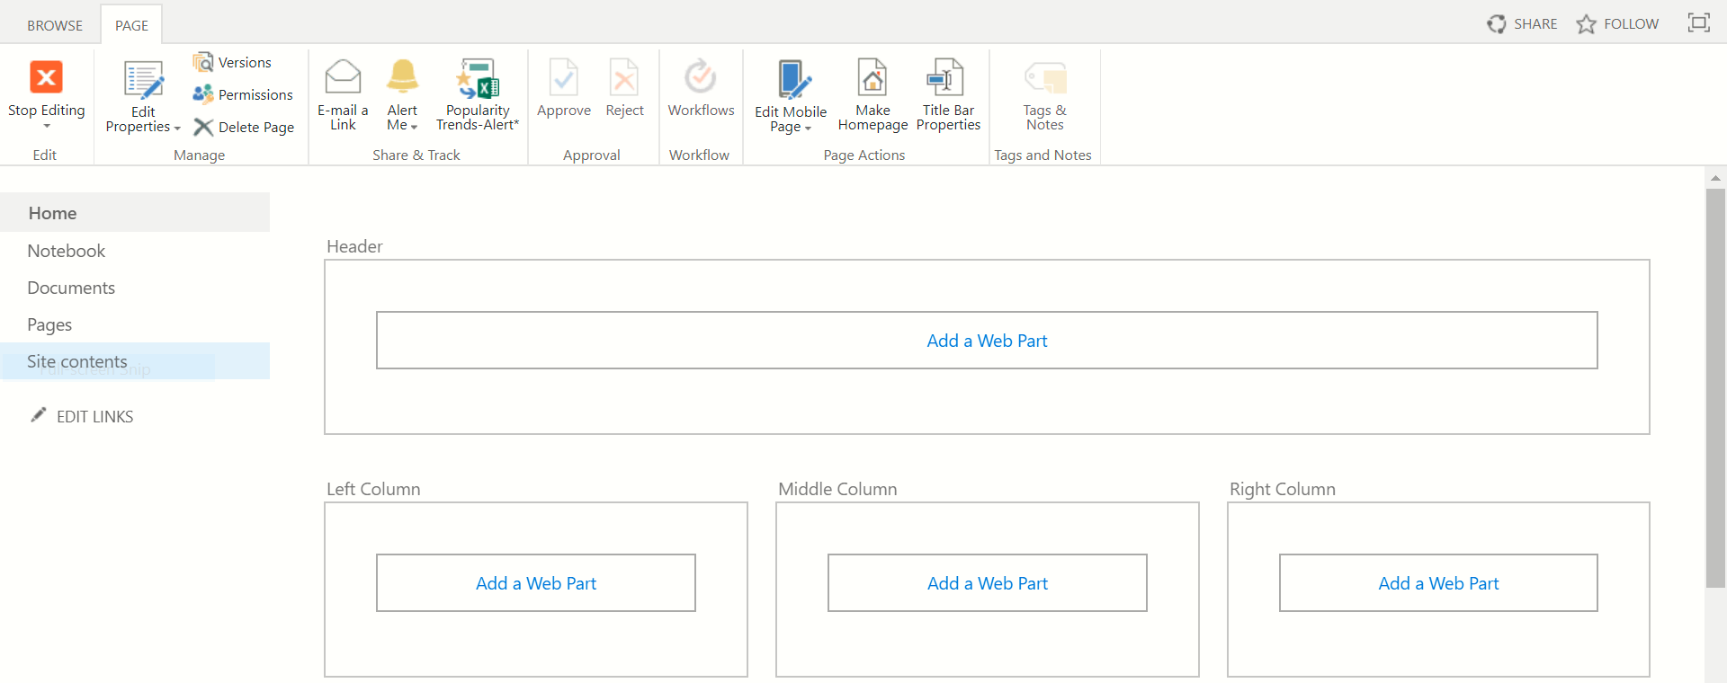

Add a web part**:**

**Media and content**

Click one of the 4: to use meaningless words to our web part we use ( lipsum.com )

Add a web part => media and content => content Type =>copy some doc. From lipsum.com =>click here to add a new content

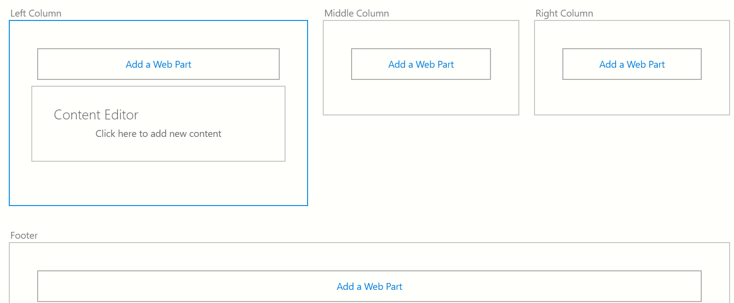

#### To cancel Content Editor

Go to Appearance and cancel Content Editor then Apply

And paly on it when we finish close Editing (page => Stop Editing).

**NB:** read more SharePoint 2013 OOTB at Google drive.

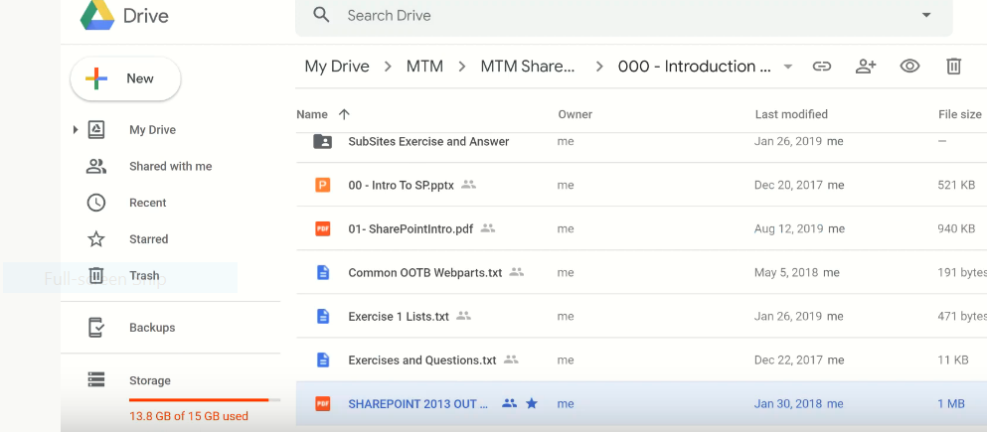

If we didn’t find some summary links. We use ( summary links web part missing SharePoint 2013 => [Upgraded sites missing Summary Link Webpart](https://social.technet.microsoft.com/Forums/office/en-US/dd6fc69c-2436-445e-9c19-9d673e6ad3bc/upgraded-sites-missing-summary-link-webpart) ) to search the reason why we miss them? Or use the above drive doc.

**Let us see the the following categories:**

1.Apps**: For most Lists and Libraries**

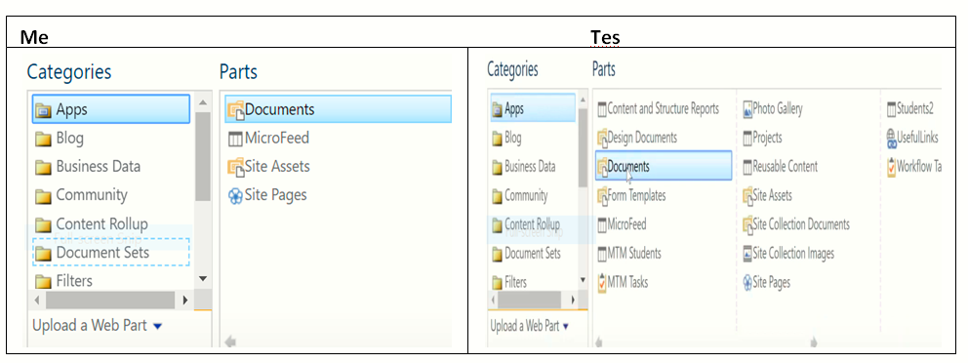

Examples**: there are two lists**

**List1:**

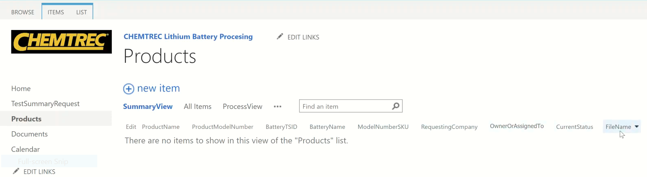

**When we start to write the name of the person the system bring choose**

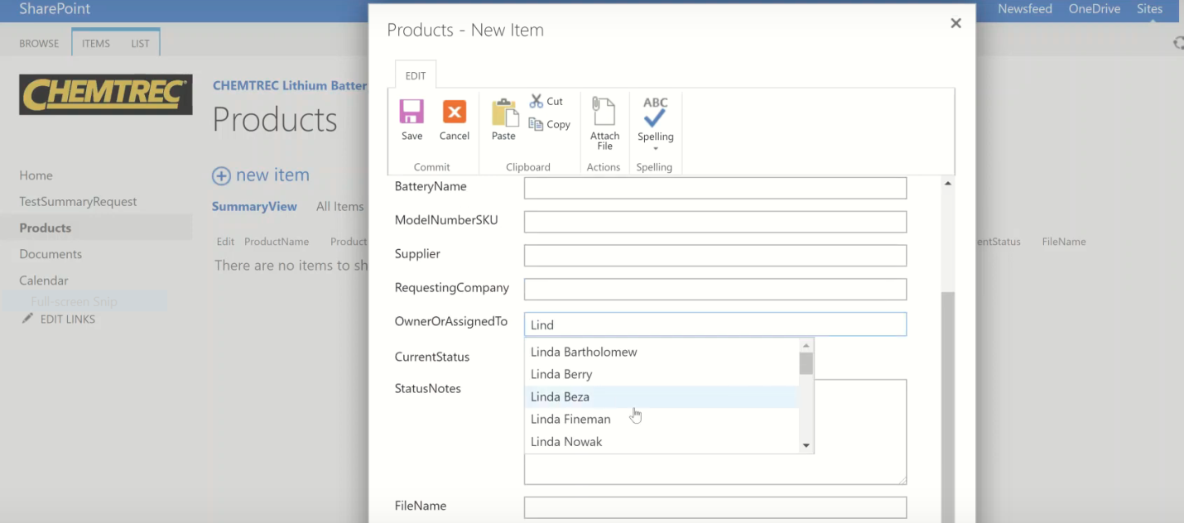

Create Datasheet view: it is easy to Edite

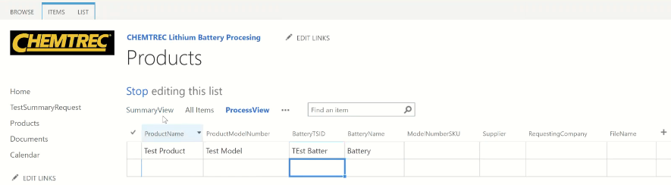

**List2:**

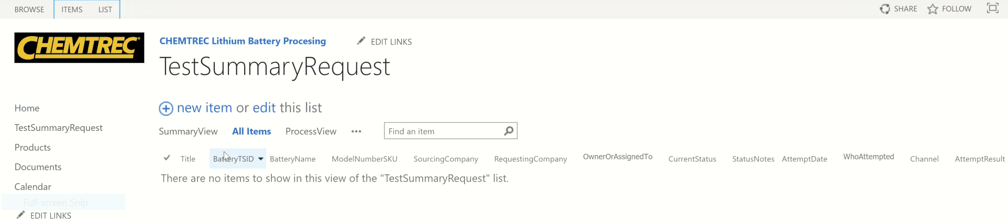

We use the same fashin as the top,

We create small navigation for them

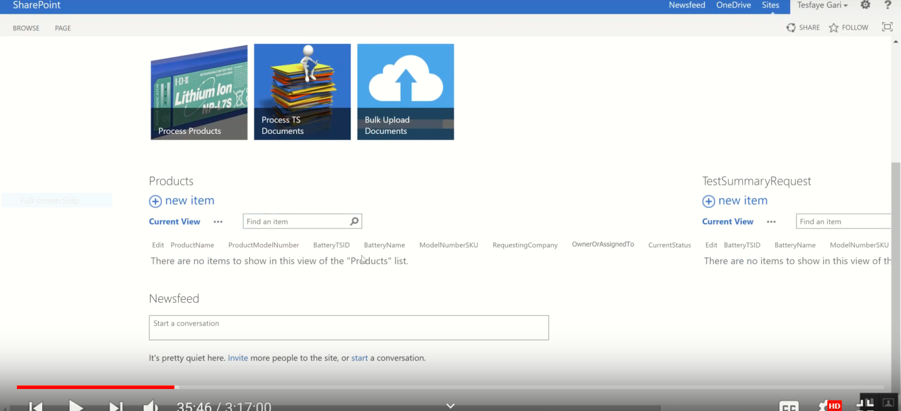

2.Blog**:**

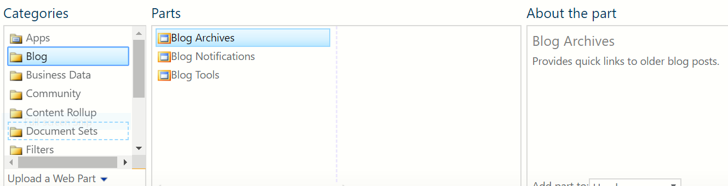

**3. Bussiness Data: To use more excel**

3.1. Business Data Action: For indicators

3.2.Excel web accesses

**4. Community:**

5. Content RollUp**: Important**

To display the value of subsites at Demo

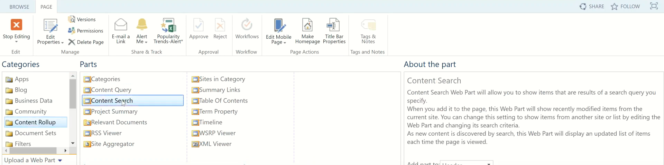

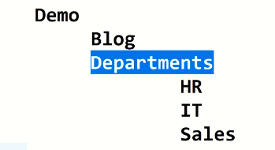

4.1 Content Search**: Search across the board**

* Target Aodiance => to make group

Sign of person next to Target Aodiance => select the group, show the following

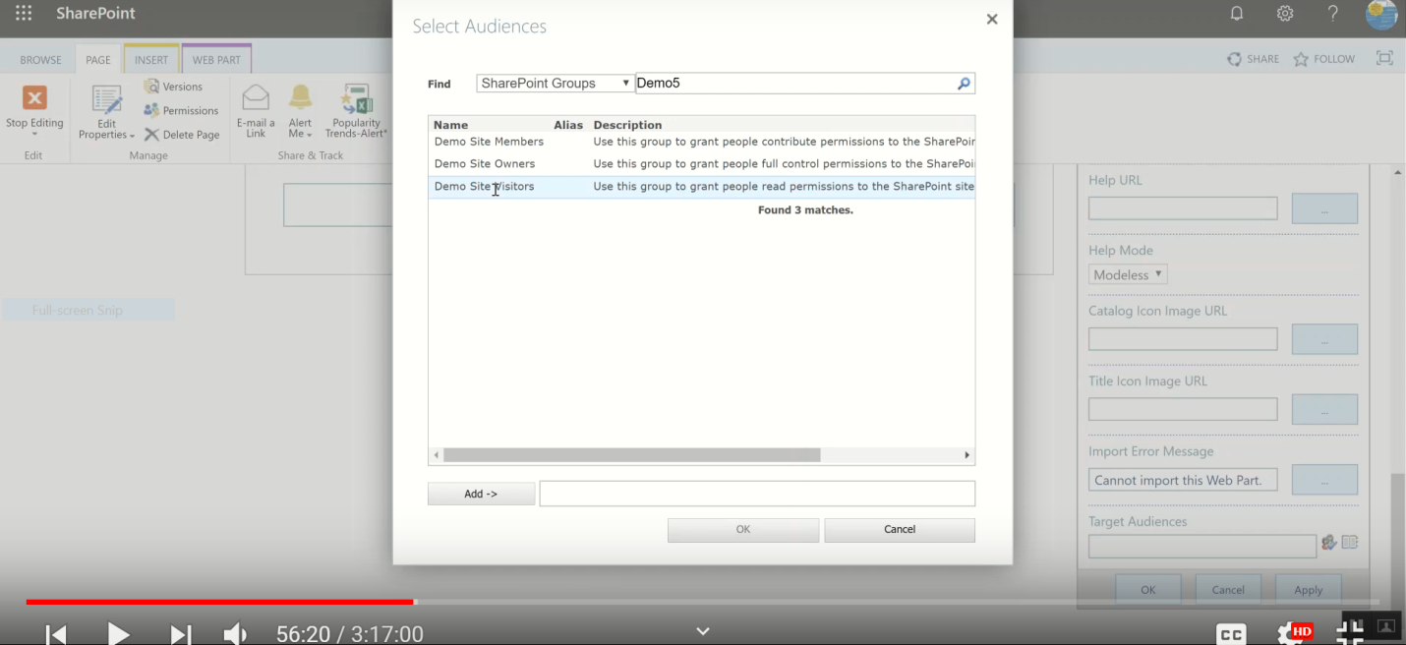

**The following 3 buttons used for all web parts**

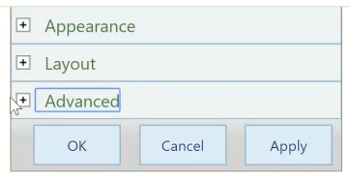

* **Change Query: which kind of Document we bring (picture, Text…)**

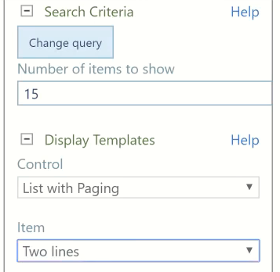

And we can increase the number of items to show.

We can display images by slideshow or we can display videos

canged Query

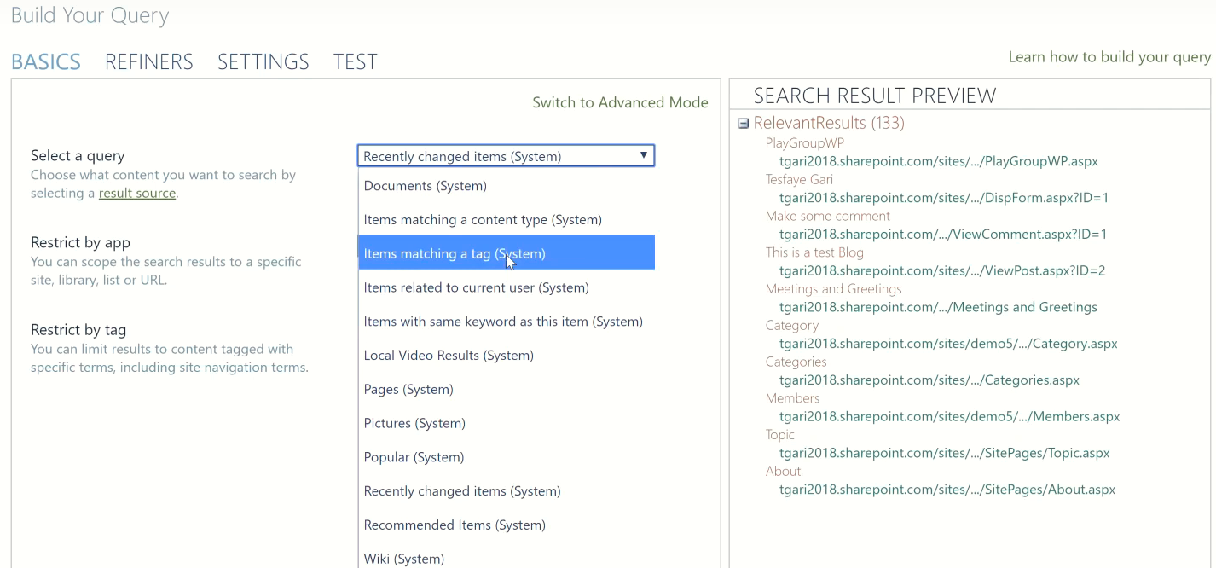

Table of content: link navigat

Summary Links**:**

**publishing site, not related with lists & libraries**

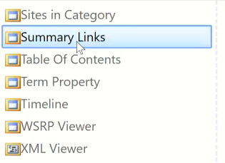

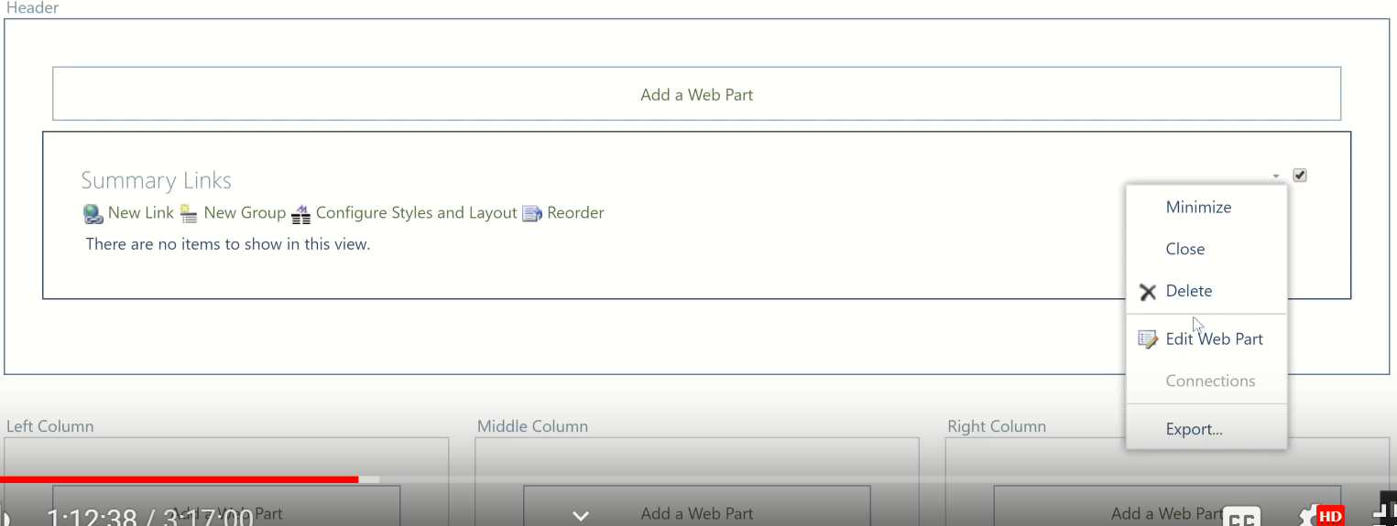

**To change Summary Link Title**

Edit Web Part => Appearance , then change the name of the title => apply

### Configure style and layout

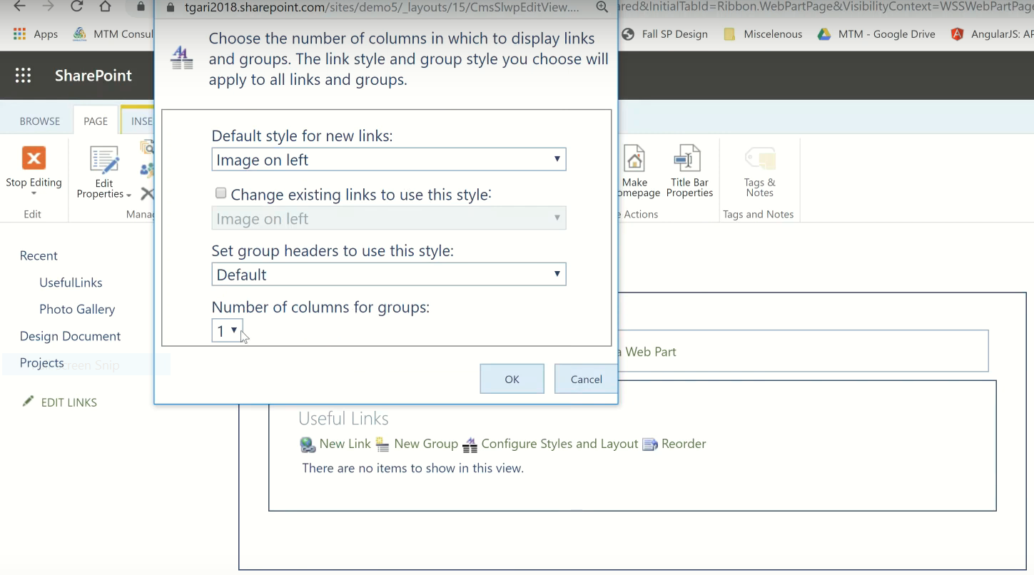

New Link**.**

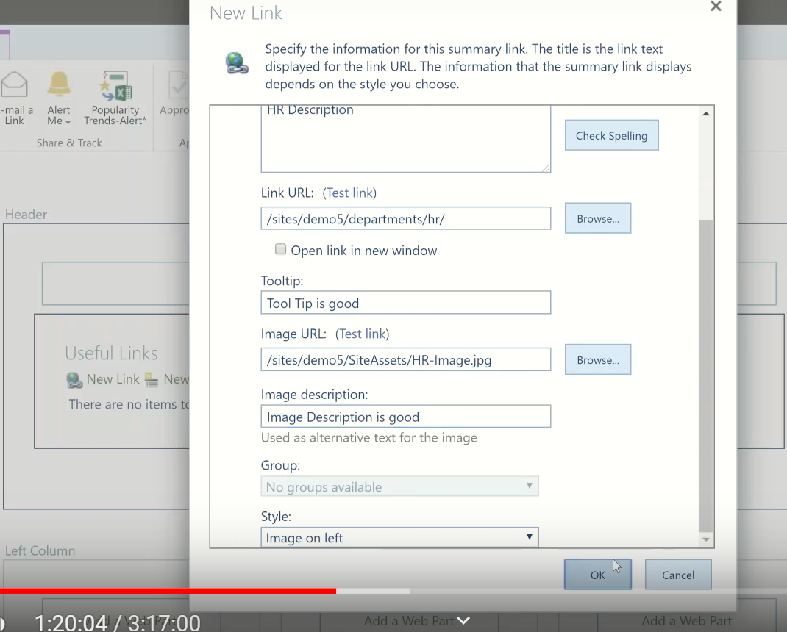

**To manege Image:**Click Check box before HR => Under Image the left fix image size

**To add other link:** Use New Links

**To delete or Edit the page:** Page => Editing => Edite

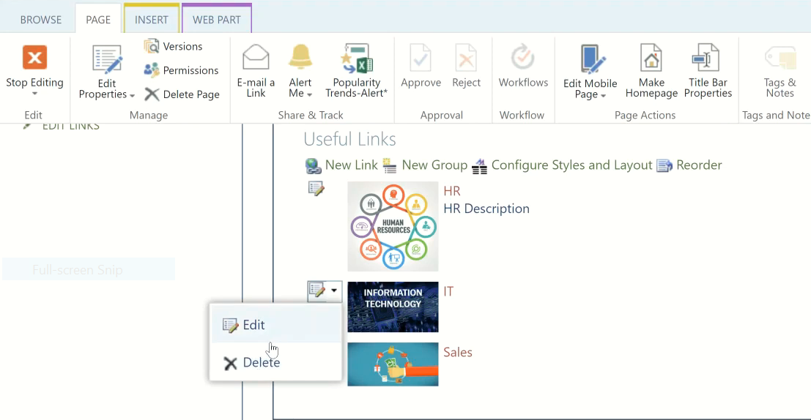

# Promoted Links

Add an app =>promoted Links =>list at the top => Tile => All promoted Links

New

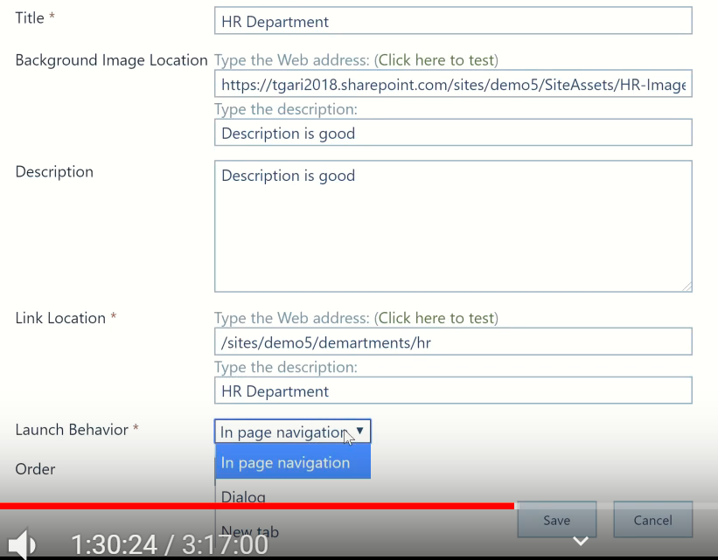

To add new Item:

Item => New item => New

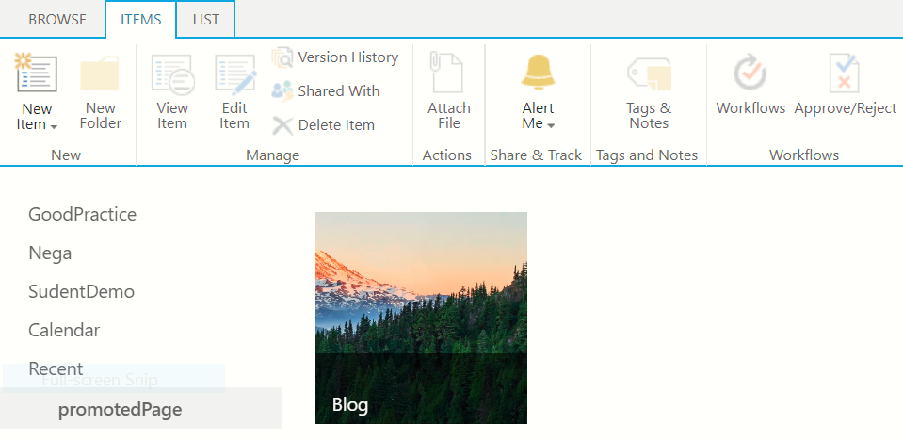

## To add Promoted Link to web parts

Setting => site content => site pages => open your page =>Edite a page on the page =>Add a web part then Add our promoted Link

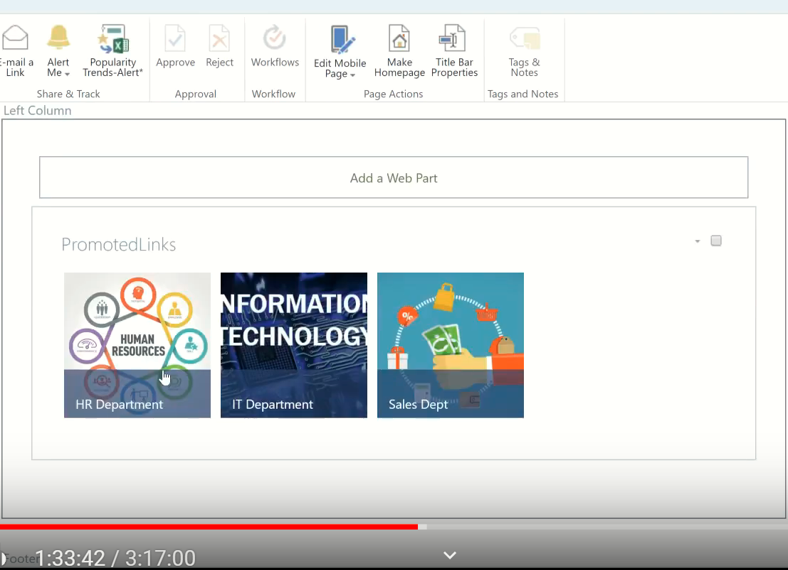

### To change the Image

Go to promoted Link =>Item => All promoted link =>click the edit button before HR =>then you can do anything

To add Edit: modify => Edite=>

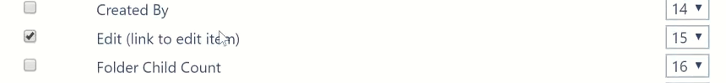

(1:43hr up to 2:06hr brake)

RSS Viewer**: it bring doc. Out side SP.**

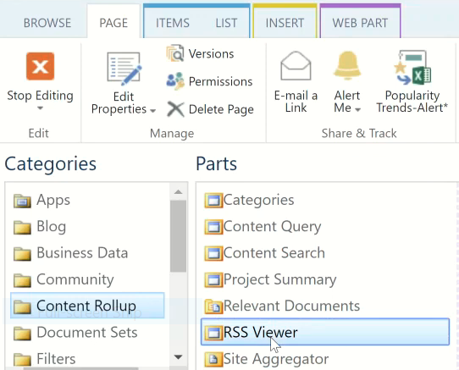

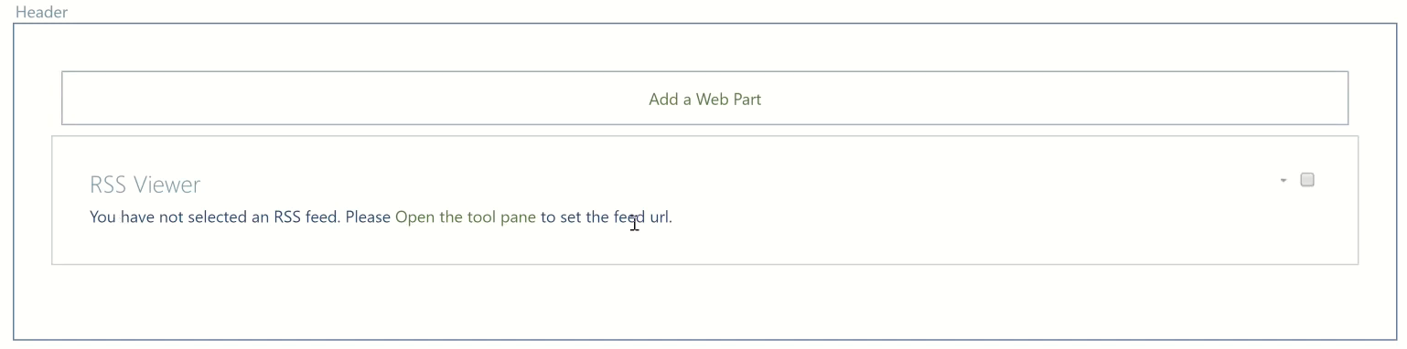

Eg. Used for News

**cnn rss feed =>** [**RSS (Really Simple Syndication) - CNN.com**](http://www.cnn.com/services/rss/) **=>** <http://rss.cnn.com/rss/cnn_us.rss>

To add it in to the page Use http://rss.cnn.com/rss/cnn_us.rss link**Check What Kind of source it has:**

Open ” http://rss.cnn.com/rss/cnn_us.rss “ =>right click on it => View page source

**Where we put RSS URL:** http://rss.cnn.com/rss/cnn_us.rss

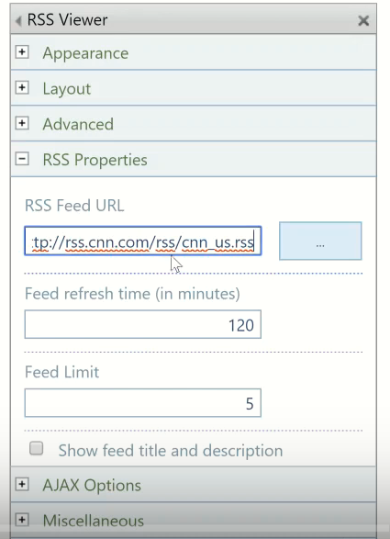

**Content and RollUp:**

## Filter: Query String:

Query String is the statement /at the end of URL after Question mark.

It is not a part of URL

It has a parameter and value

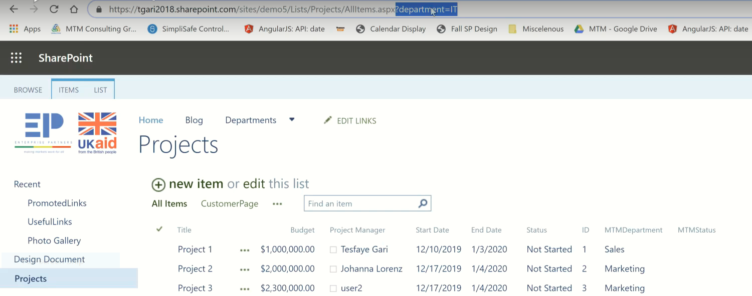

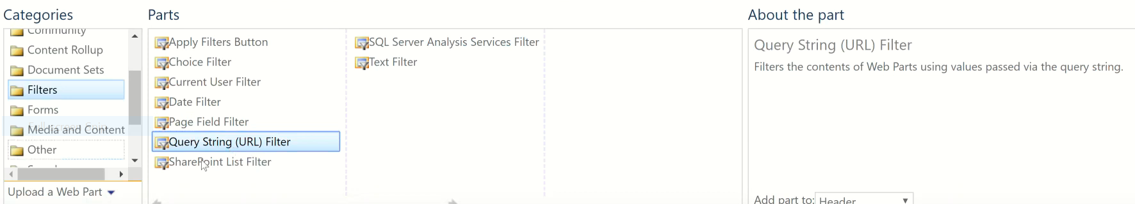

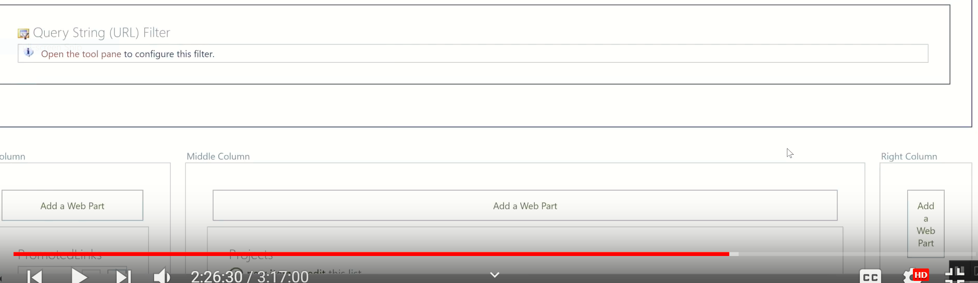

**By tuching:** Open the tool pane to configure this filter

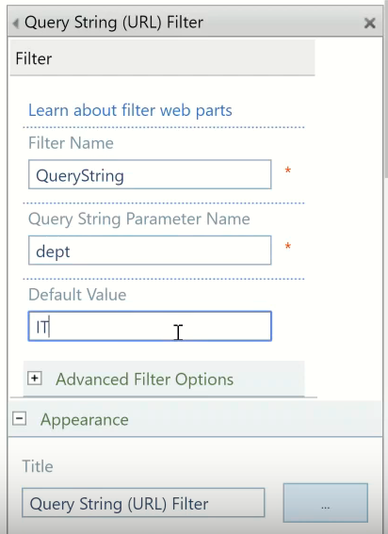

**To change The Place of the Doc. Use the following Under layout**

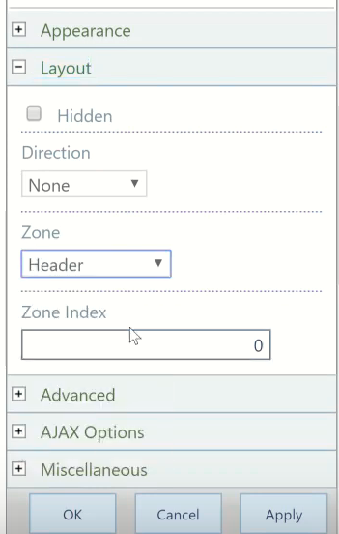

**Look the query: Prater = dept, Value = Sales**

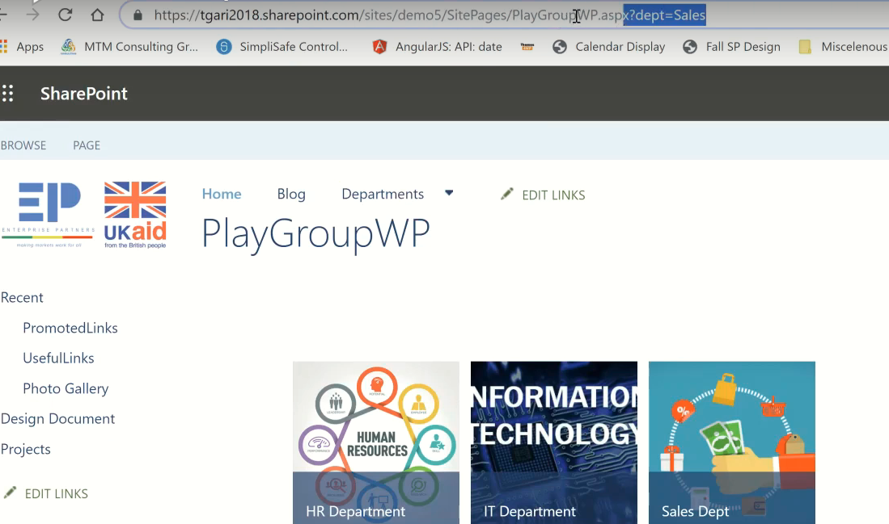

**To filter only sales from the following Doc.**

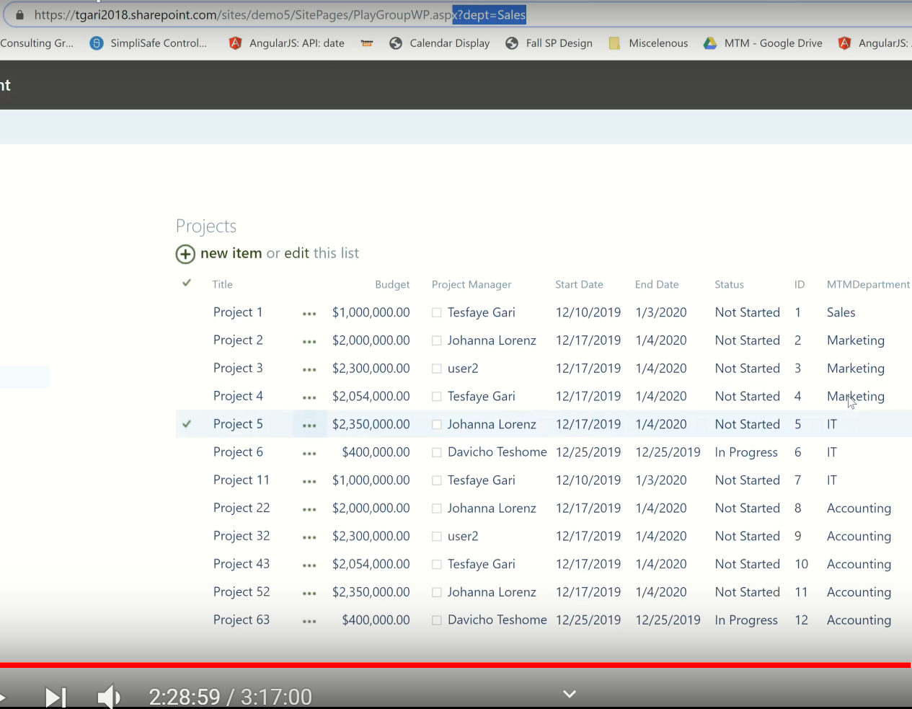

**Setting => Edit page => “Edit web part” on the page**

**First to connect two parts of web page**

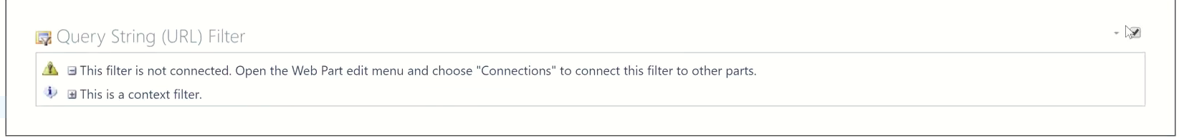

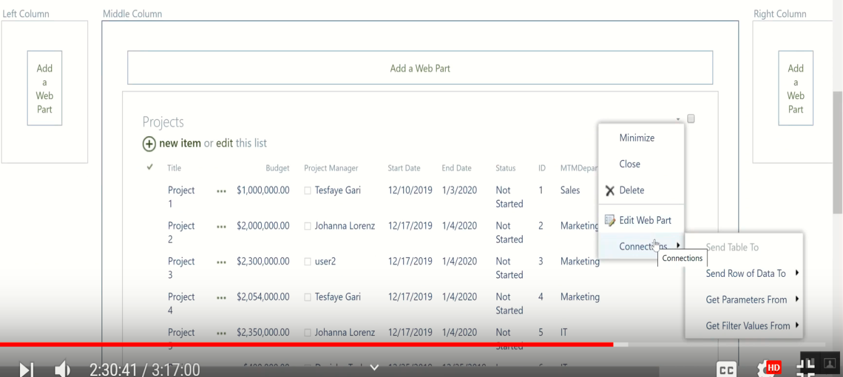

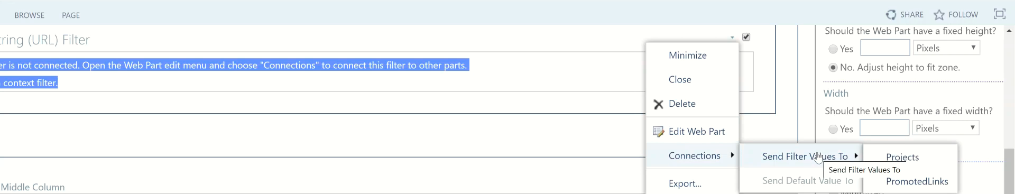

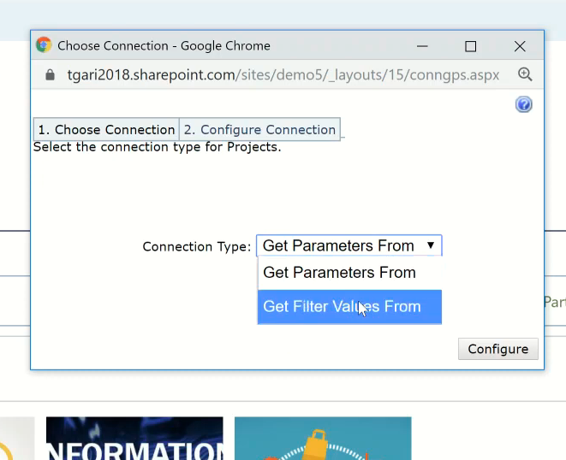

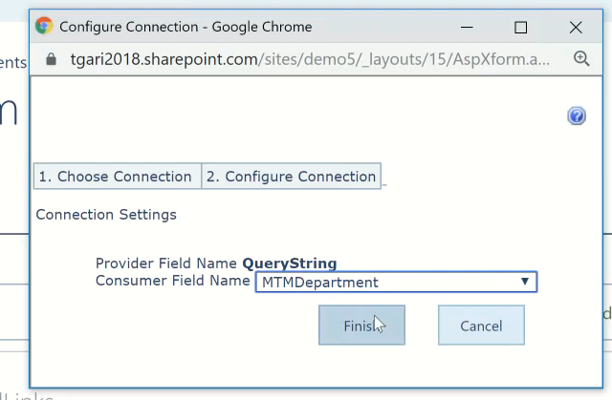

Then we get the result

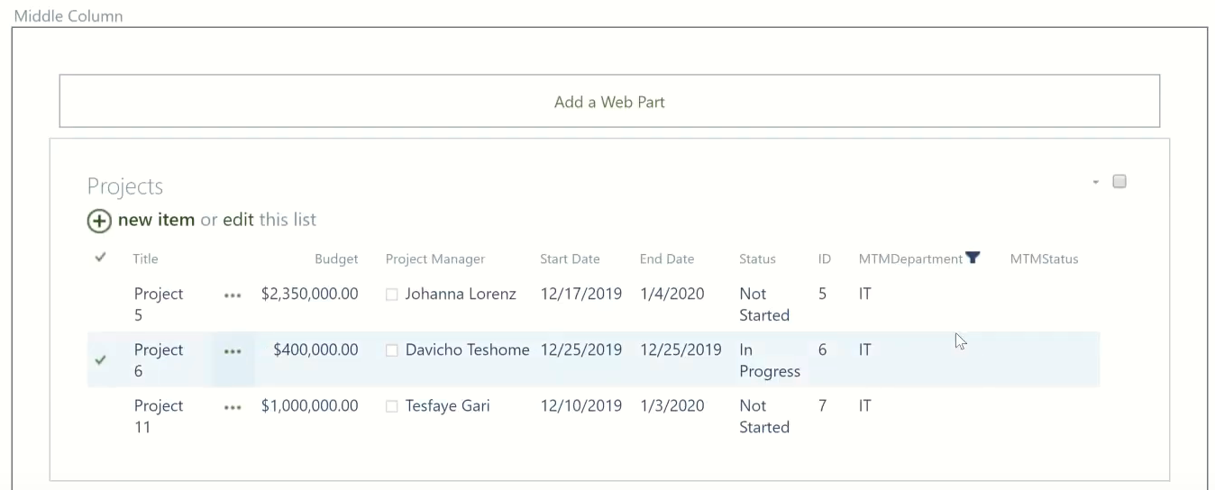

Then we can filter by changing the value (IT , Marketing , Sales..)

Media and Content**:**

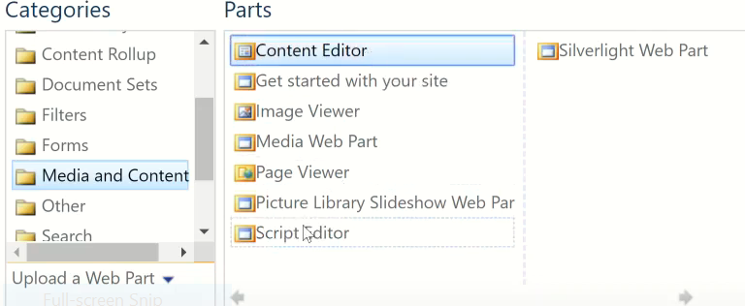

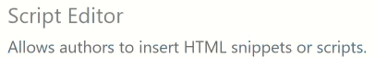

Eg.

Go to any yutube Library =>open any Vedio => Share =>Embed =>the we get HTML snipet

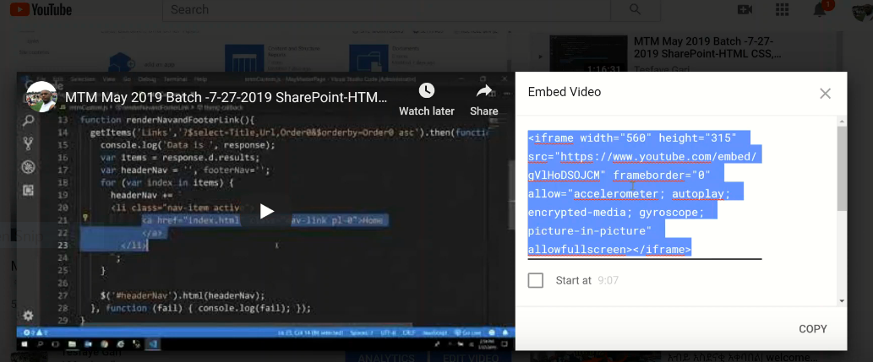

Add Script Editor**: click Edit**

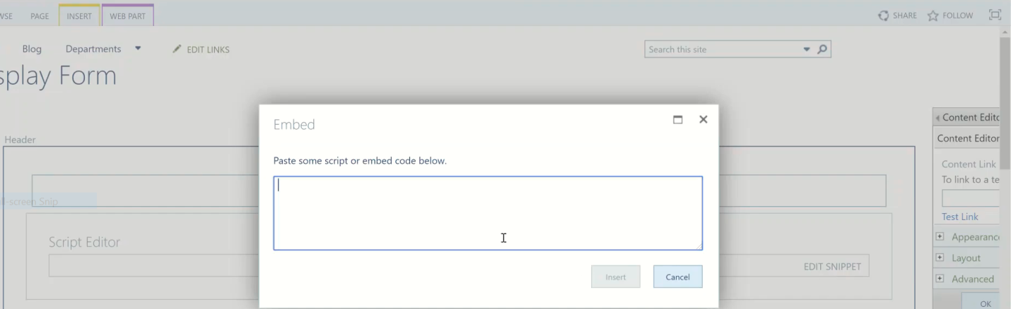

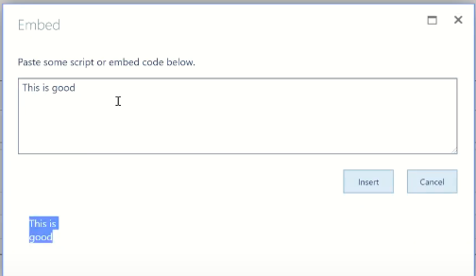

The we get the ff result(NB: we add our HTML <h1> </h1>)

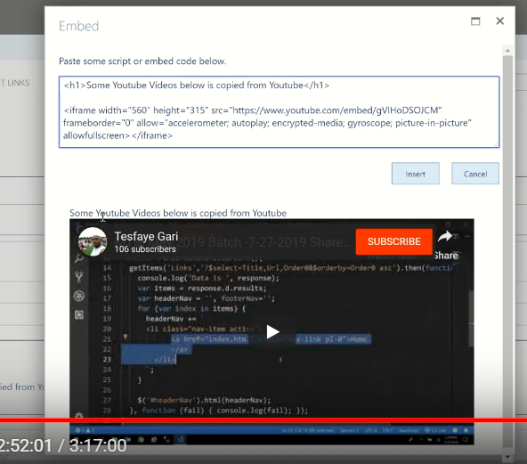

## Add Content Editor

**To add any contents & the page looks like Word**

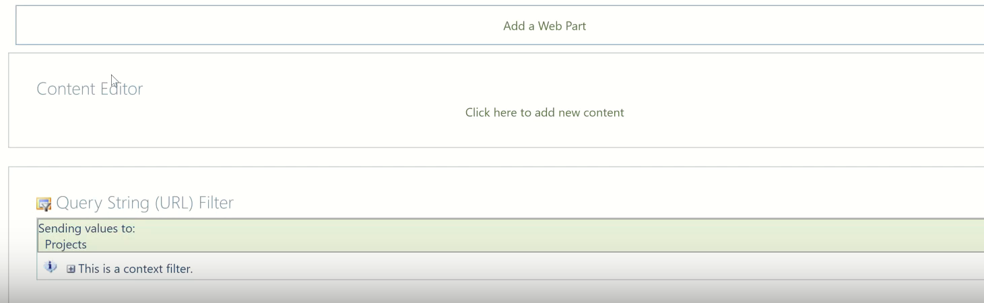

It is the same to wiki page, so somebody can deleted the file easly so we put some where our Doc.

## How to Add content Editor page by Link

**Case 1:**

Eg.

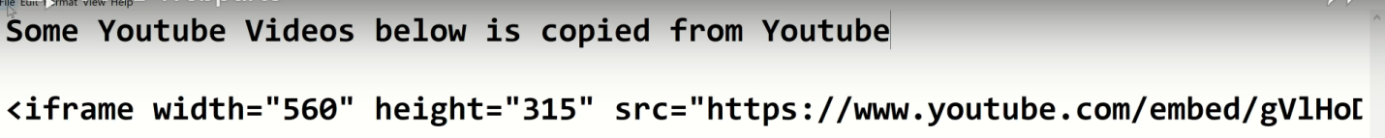

Goto one vedio => copy URL => paste on Note pad & add some title at the top => File => save as => Demo Document (Folder->File name) => then we have to grap and drap to site assete and then we use URL to Content Editor.

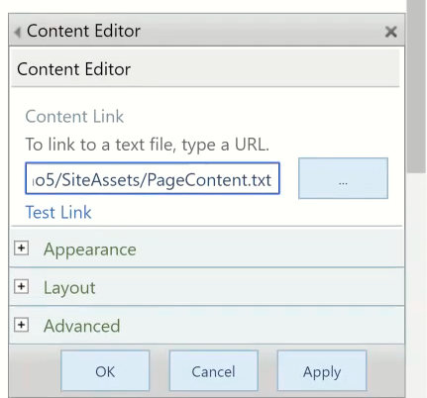

Then we get like bellow, that is not editable

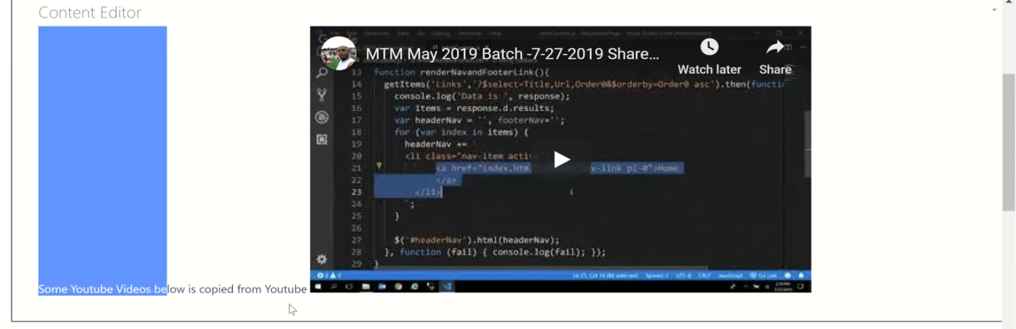

**Case 2: Edit source =>paste URL**



The only diff is the second one be deleted by clicking delete button.

But If you paste simply URL on Content Editor page that’s not work. Look ff

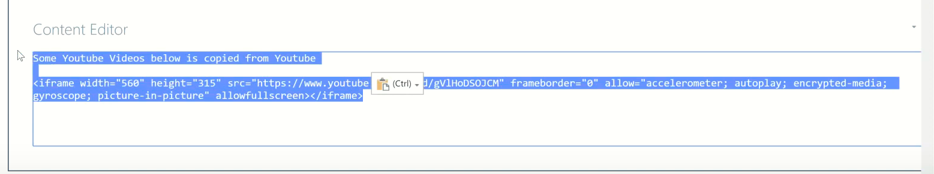

**Weather:**

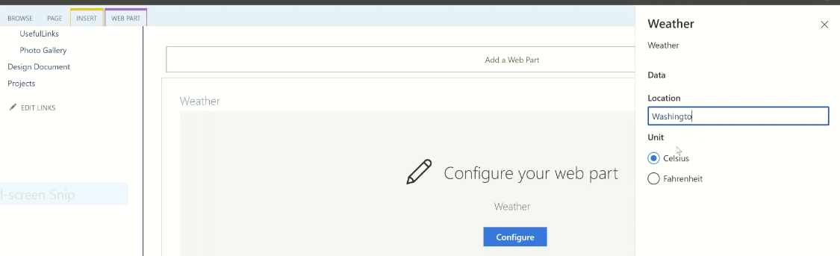

NB:

1. Query String = Parameter and value
2. # hash tag

Eg. # : Google => Africa => instead of

<https://www.google.com/search?sxsrf=ACYBGNSOLDOQ0XkKvS9yu5wIOXmqg61GSA%3A1576616545925&source=hp&ei=YUL5XcnNNaXb5gKSlJiwBw&q=Africa&oq=Africa&gs_l=psy-ab.3..35i39l2j0l8.1981.3762..4371...1.0..0.139.707.0j6......0....1..gws-wiz.......0i131.CKwNA0mdz4c&ved=0ahUKEwiJgqipyr3mAhWlrVkKHRIKBnYQ4dUDCAg&uact=5>

we use

<https://www.google.com/search#q=Ethiopia>

**Every Lists Has Form:**

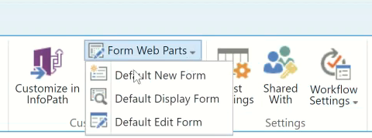

**End of Class9**